Worksheet


Items highlighted in yellow are tasks for you to complete
Items in Blue italics are help tips

Feelings Graphic Design Y9

Using Inks Crayons or Paint create four small pictures that express a feeling i.e. Anger, Speed, Peacefulness, Winter (you decide)

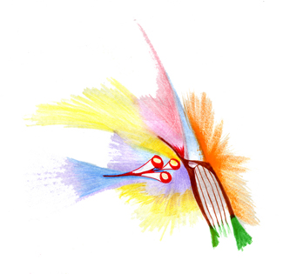Speed

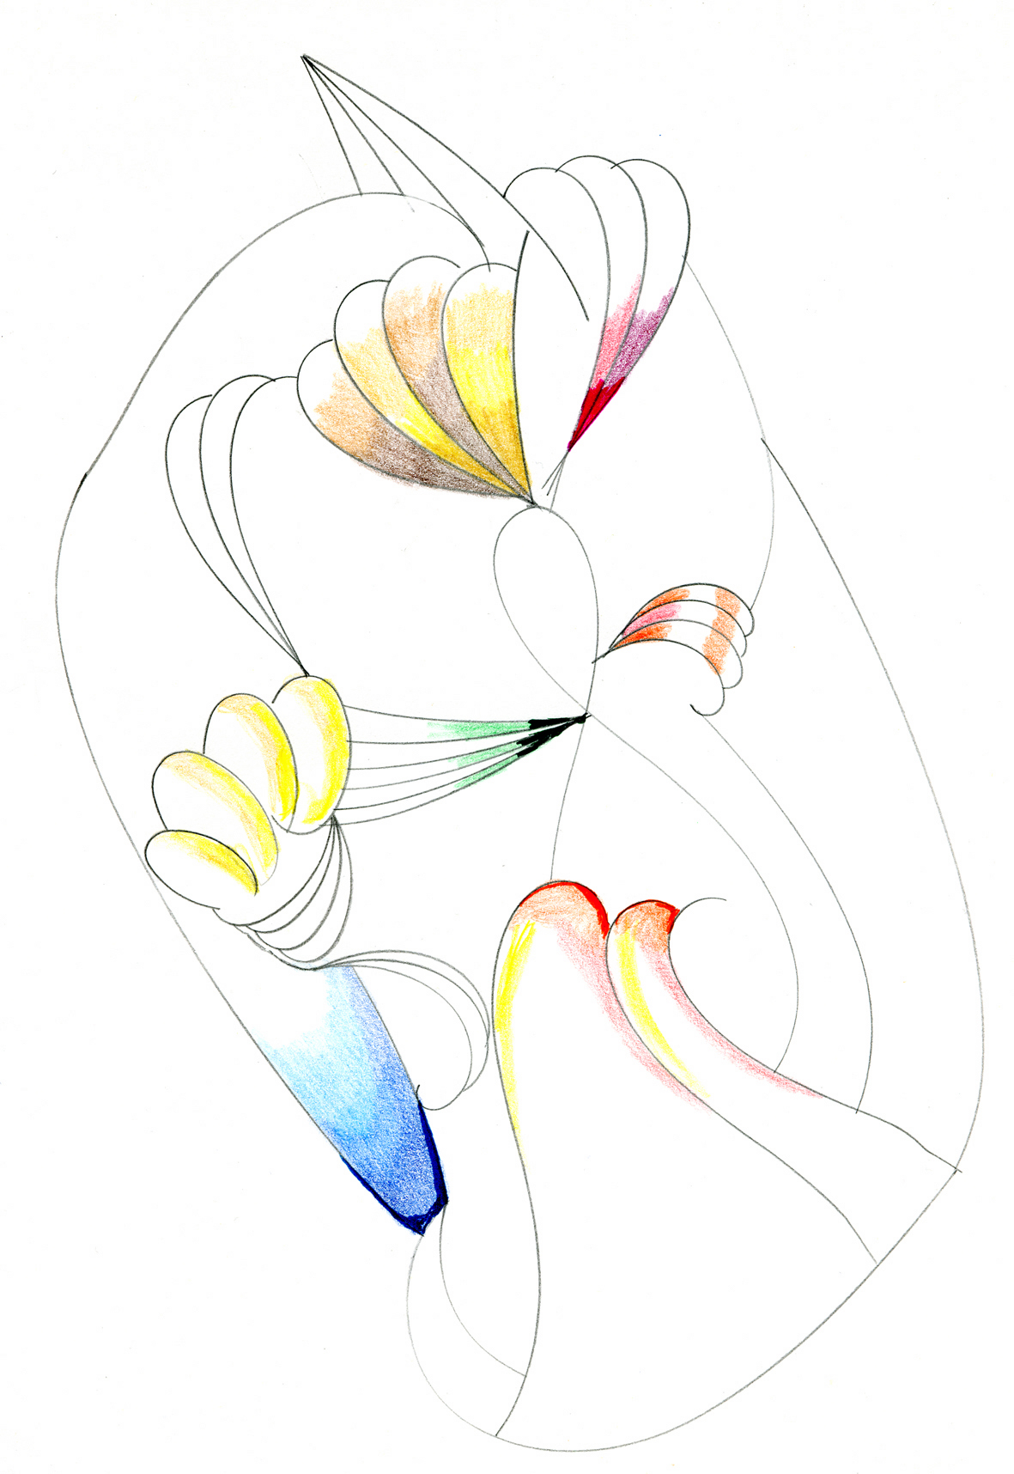Love

Need help just ask

